**Student Questions**

Learn about the internals of a standard PC case by examining physical samples and selecting and labeling images found on-line. Gain deeper knowledge by researching and reporting on specific components.

PC Tower Case

1. Find one (or more) images that clearly show the internals of a PC Tower Case.

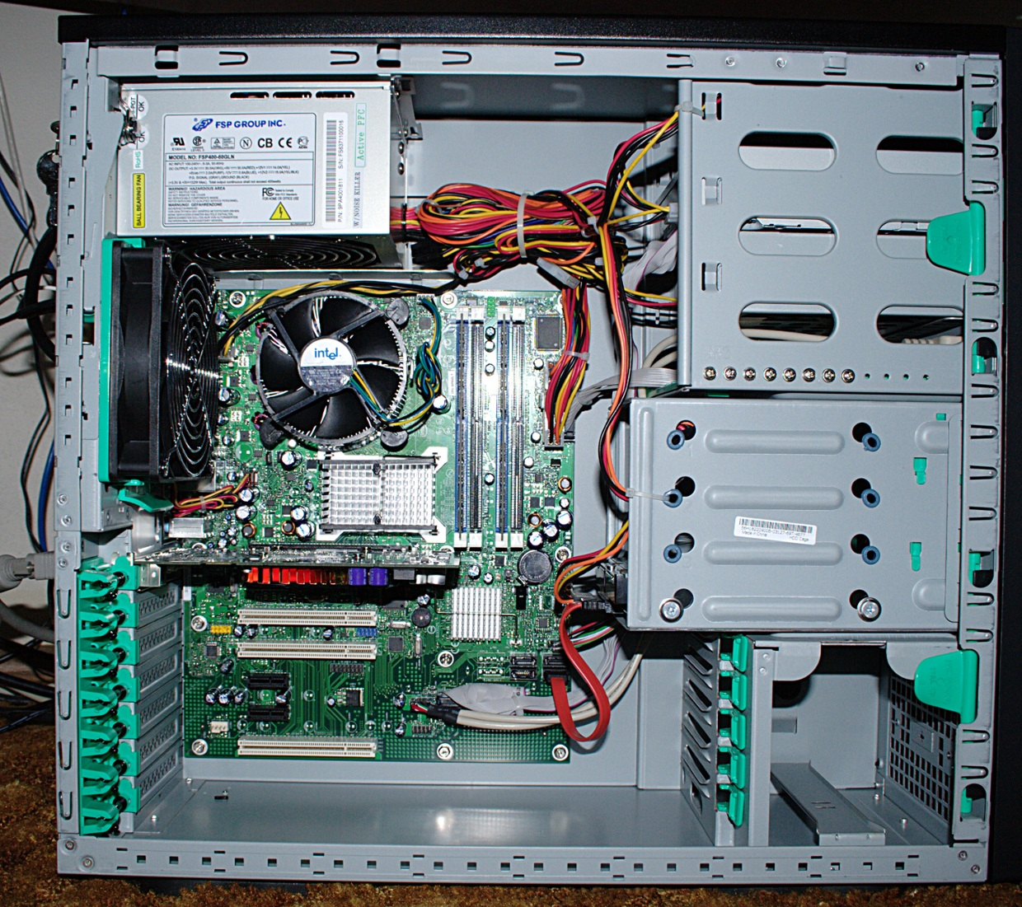

1. Clearly label the following components (using arrows) on your image of the PC case internals:
   1. Motherboard
   2. Power Supply
   3. Hard Disk Drive
   4. Optical Disk Drive (e.g.DVD)
   5. USB Expansion Ports
   6. Monitor Port
   7. Audio Ports
   8. Ethernet Port
   9. Cooling Fan
2. Research more in-depth about “Hard Disk Drives”. Make notes on the following:
   1. What different versions are currently available (speed and capacity)?

There are many different versions currently available online and at retail stores near by in Brampton. They all vary in speeds and capacity depending on their price, such as the Serial ATA (SATA), Parallel Advanced Technology Attachment (PATA), Small Computer System Interface (SCSI). You don’t have to get an HDD because SSD’s are better, faster, and mostly have more storage. Some of these capacities for HDD’s and SSD’s are 100GB, 500GB,1-4TB. There are also 5400RPM and 7200RPM drives, which are standard disk speed.

* 1. How the capacity of the component has changed since the 1980’s?

The capacity of HDD’s has changed a lot, where in the 1980’s a hard disk drive was only able to hold 1MB. But nowadays hard disk drives can hold up to 4TB of storage, such as games, photos, videos, and other applications on the desktop.

PC Motherboard

1. Find one (or more) images that clearly show the layout of a PC Motherboard.

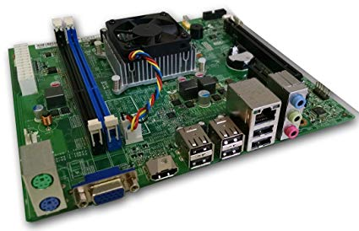

1. Clearly label the following components (using arrows) on your image of the PC motherboard:
   1. CPU (and fan)
   2. RAM Memory
   3. Disk Drive Interface (IDE or SATA)
   4. GPU Graphics Processor (either on-board or Graphics Card)
   5. Sound Processor (either on-board or Sound Card)
   6. Wi-Fi / Ethernet Network Interface (either on-board or Graphics Card)

1. Research more in-depth about “CPU Processor Chip”. Make notes on the following:
2. What different versions are currently available (speed and capacity)?

There are many different CPU’s with different versions, speeds, and capacities such as quad core, octa core, 12 core, 16 core, and sometimes even 32 cores. The two main competitors that produce and sell microprocessors for computers are Intel and AMD.

1. How the speed of the component has changed since the 1980’s?  
   In the 1980’s, microprocessors had a very slow speed of 8MHz, which is very slow compared to speeds nowadays. Currently basic chip’s speed is 3GHz and a laptop is around 2Ghz – 3Ghz.

Peripheral Devices

1. Find one (or more) images that clearly show the layout of the back of a typical PC tower case.   
     
   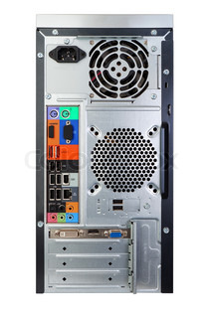
2. Clearly label the following components (using arrows) on your image of the back of a typical PC tower case:
   1. Power cord and power switch
   2. Monitor Interface (VGA or DVI or HDMI)
   3. Mouse Interface (USB or PS/2)
   4. Keyboard Interface (USB or PS/2)
   5. USB Ports
   6. Audio Inputs / Outputs
   7. Ethernet Interface

1. Research more in-depth about “External Portable Storage”. Make notes on the following:
2. Floppy Disks

Very outdated storage device, it holds low amounts of storage.

1. CD-ROM / DVD / Recordable CD/DVD

Sort of outdated, can hold up to 1-10GB of storage. It can be written and read by using a optical device.

1. USB Memory Drives

Highly compacted, they work fast and hold high amounts of storage up to 256Gb. They are used by being plugged into the PC using USB ports.

1. Compact Flash Memory

Very fast storage, highly compacted. Read and write speeds very efficiently, it can be put into a SD card reader in a PC or laptop.

1. Cloud Based Storage  
   Stores files in a remote server room, not in a PC’s hard disk drive or solid state drive. It is virtual storage which can be accessed online by using a web surfer such as Chrome and going to these cloud based storage such as Google drive or Microsoft OneDrive.

**Presentation Outline**

Explore the development and features of a specific PC hardware component through deeper research and investigation. Work in partners to create a short presentation. Deliver the presentation to the class.

Each group will research a unique PC hardware component. Your specific topic will be assigned from the list provided below.

**Presentation Structure**

1. Explain what the PC component does and how it fits together with other components to make up a fully functioning PC.
2. Explain how the PC component works. Provide a diagram (image) showing the main parts of the component.
3. Research the current state of the art of the component in terms speed, capacity (size), and other related factors.
4. Research on-line suppliers that sell the PC Component. List the specifications for the available products and the cost (price).
5. Research how the PC component has changed and evolved since the early days of PCs in the 1980’s. Cover each of the following topics separately:
   1. Component Speed
   2. Component Size / Capacity
   3. Two other specifications specific to the PC component (ask Mr. Nestor)

**PC Component Topics**

|  |  |  |
| --- | --- | --- |
| **Topic** | **Partner 1** | **Partner 2** |
| CPU Microprocessor Chip |  |  |
| Motherboard Layout |  |  |
| Computer Graphics |  |  |
| Sound & Audio |  |  |
| Hard Disk Drives |  |  |
| Removable Disk Storage |  |  |
| Ethernet / Fiber Connectivity |  |  |
| Wifi / Bluetooth Connectivity |  |  |
| Mouse / Pointing Devices |  |  |
| Monitor & Display Technology |  |  |
| Printers & Output Technology |  |  |